How to set-up Jaspersoft client manually.
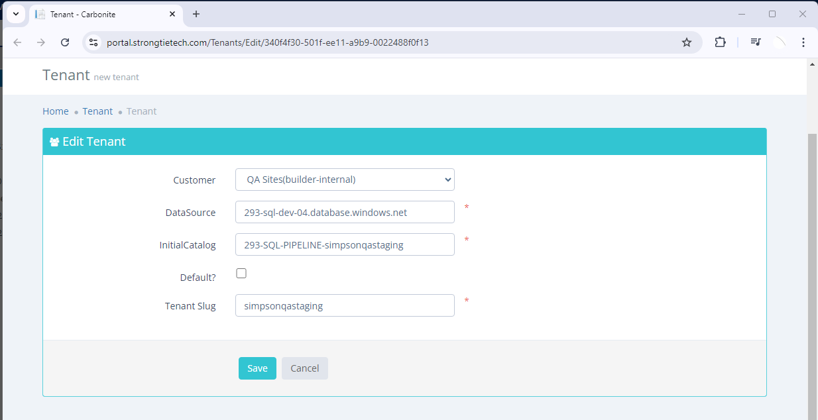
- Create a GUID to be the organization ID – probably get the tenant ID link to connection string from carbonite.

Remove the “-“ from the tenant ID eg. 340f4f30501fee11a9b90022488f0f13

- Create an organization in Jaspersoft site.
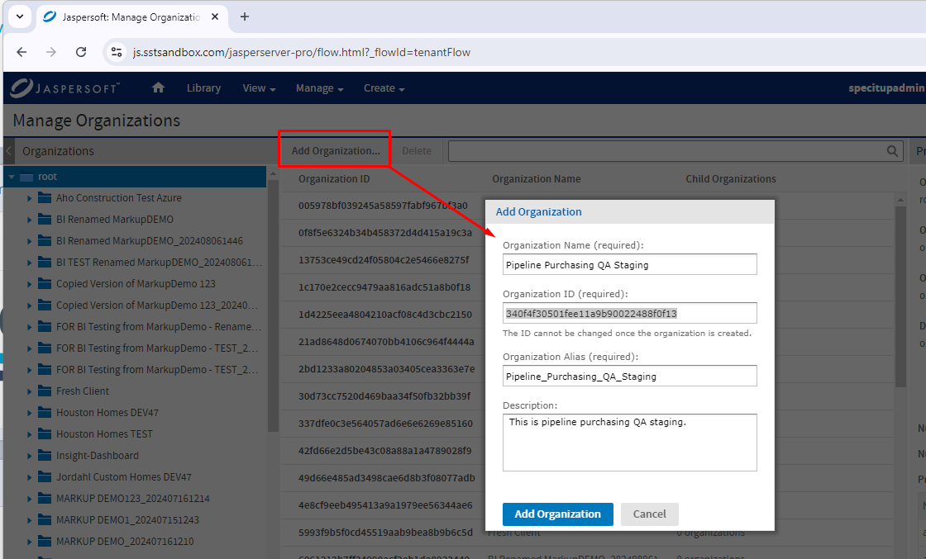

- Add the default User for the purchasing.
JasperSoft User Id: 9CE39A5E03FF4382B5F9FFC58D08E128
JasperSoft User Password: A0109FF75ACC42B095DF0FA0612C1A21

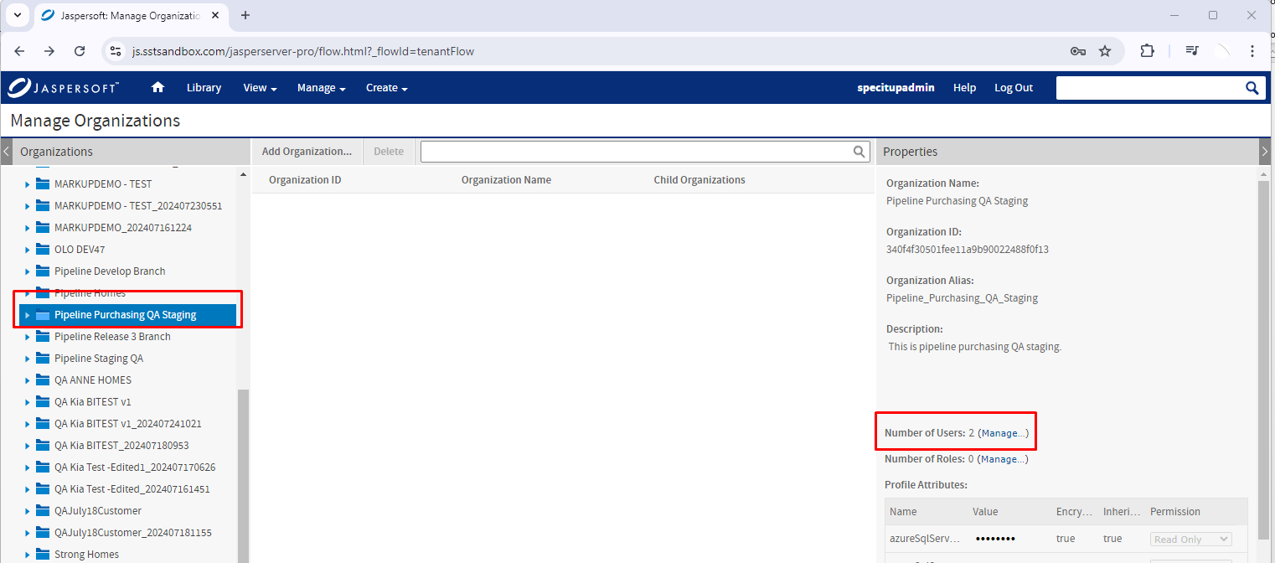
Select the newly created organization and click on the Number of Users: x (Manage…) to be able to add a new user.

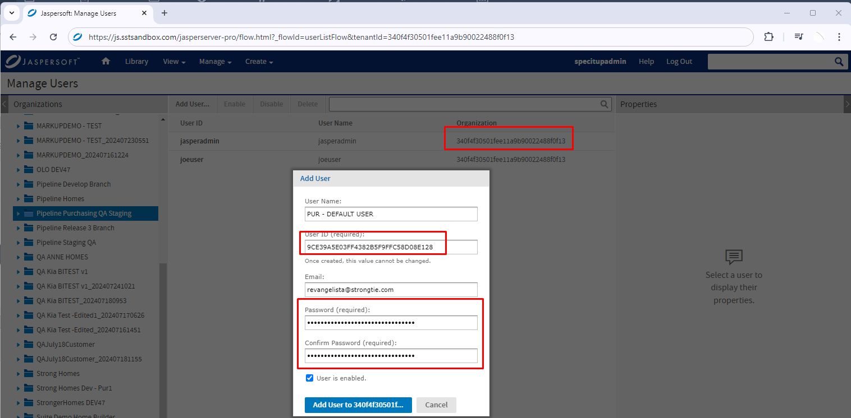

- Create attributes for Sales DB and Purchasing DB
Sales DB – holds the logo in the report.
Purchasing DB – hold the PO data in the report.
In this example I will just link the sales DB to any available sales DB since it does not require for sales integration. But once the Purchasing PO will require PO customization, the database will have to be created in sales site.
Sales Attributes needed:
specItUpDb
specItUpDbUser
specItUpDbUserPassword

Purchasing Attributes needed
pipelineServer
pipelineReportingDb
pipelineReportingDbUser
pipelineReportingDbUserPassword

Entries for Jaspersoft Dev site: (I think for specitup, the sql server hard-coded to “293-sql-dev-specitup.database.windows.net”

specItUpDb: TEST - houstonhomesdev
specItUpDbUser: siu
specItUpDbUserPassword: Put1Cep$100%

pipelineServer: 293-SQL-DEV-04.database.windows.net
pipelineReportingDb: 293-sql-pipeline-purchasingqastaging
pipelineReportingDbUser: pcms
pipelineReportingDbUserPassword: 1[cgvisions

Navigate thru Manage menu -> Organizations then select the newly created organization to create the organization attributes needed.
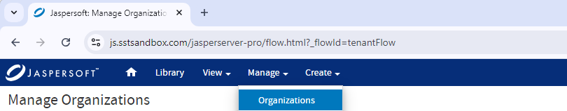

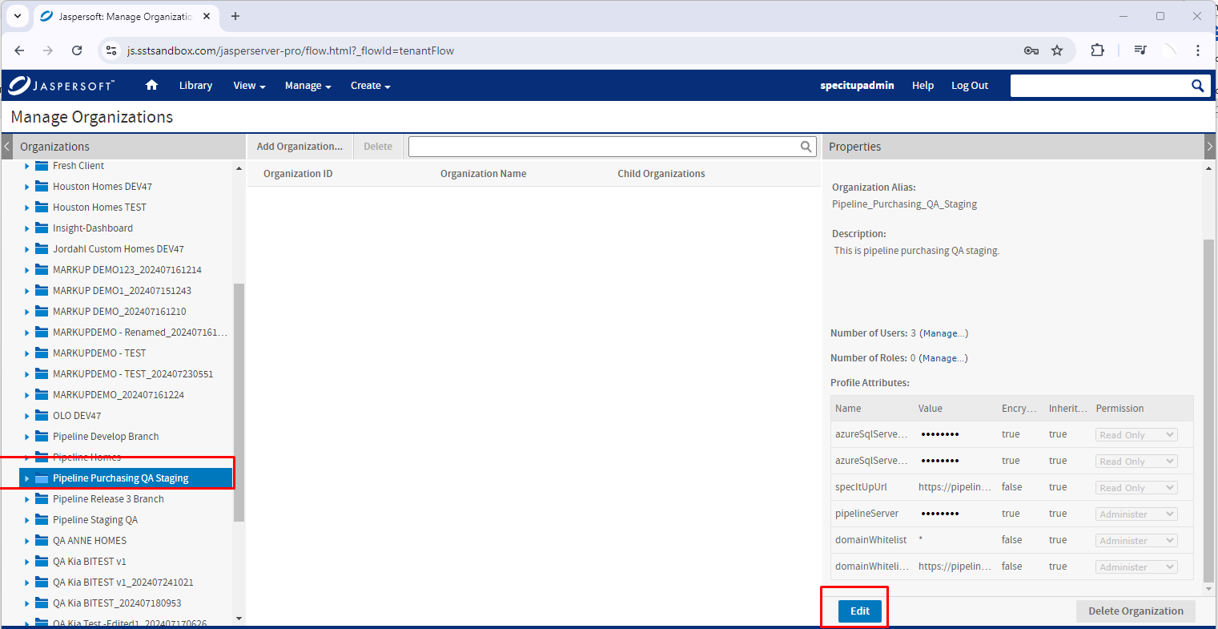

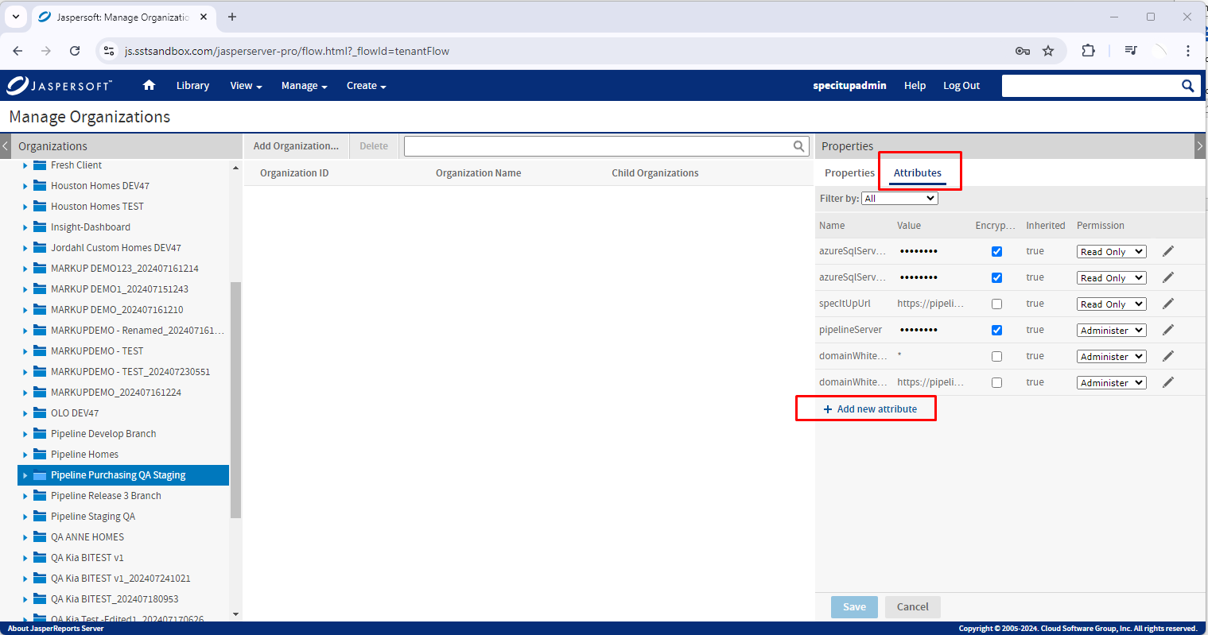

Then enter the Sales and Purchasing attributes one by one.
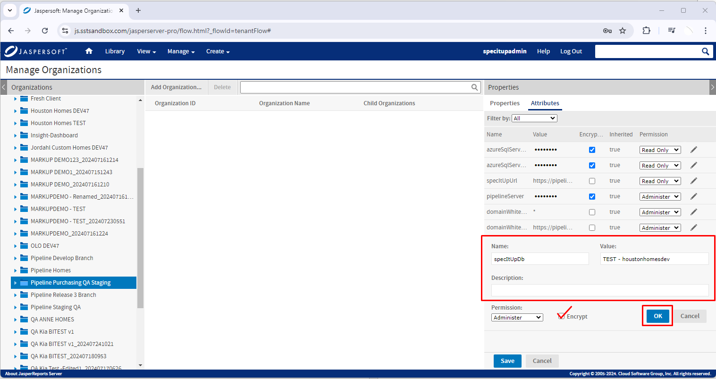
After all the attributes has been added, click the save button.
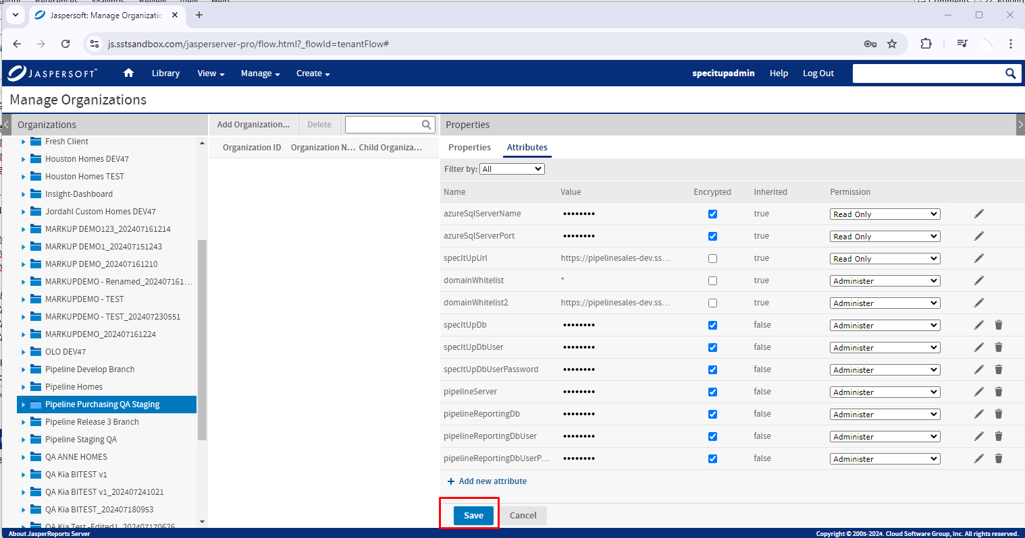

- Update the purchasing DB settings for Jaspersoft Report.


