POST Lumber> Material is failing
{
"lumCommonId": {{lumCommonId}},
"lumGradeId": {{lumGradeId}},
"lumSpeciesId": {{lumSpeciesId}},
"lumTreatmentId": {{lumTreatmentId}},
"thicknessInchesMin": 1,
"thicknessInchesMax": 3,
"widthInchesMin": 3,
"widthInchesMax": 2,
"cove": 1,
"lastModifiedUserId": 1,
"lastModifiedDateTime": "2025-07-15T20:10:04.469Z",
"enabled": true,
"isNewSecuritySplit": true,
"securityId": 224,
"masterMaterials": [
{
"legacyMaterialId": "SLMS",
"lumDimensionId": 4,
"materialCategoryId": {{materialCategoriesId}},
"materialGuid": "3fa85f64-5717-4562-b3fc-2c963f66afa2",
"materialTypeId": 8,
"name": "NLM2",
"lastModifiedUserId": 0,
"lastModifiedDateTime": "2025-07-15T20:20:55.413Z",
"enabled": true
}
],
"securityIdNew": 260
}

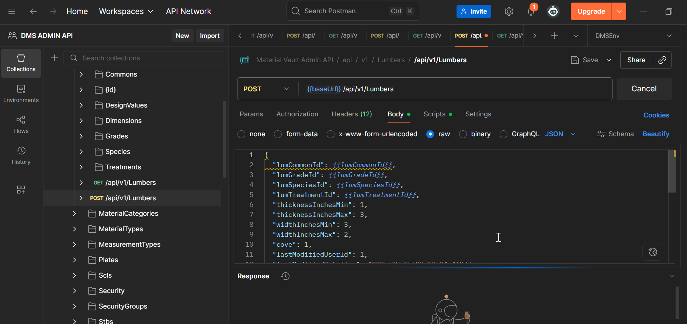
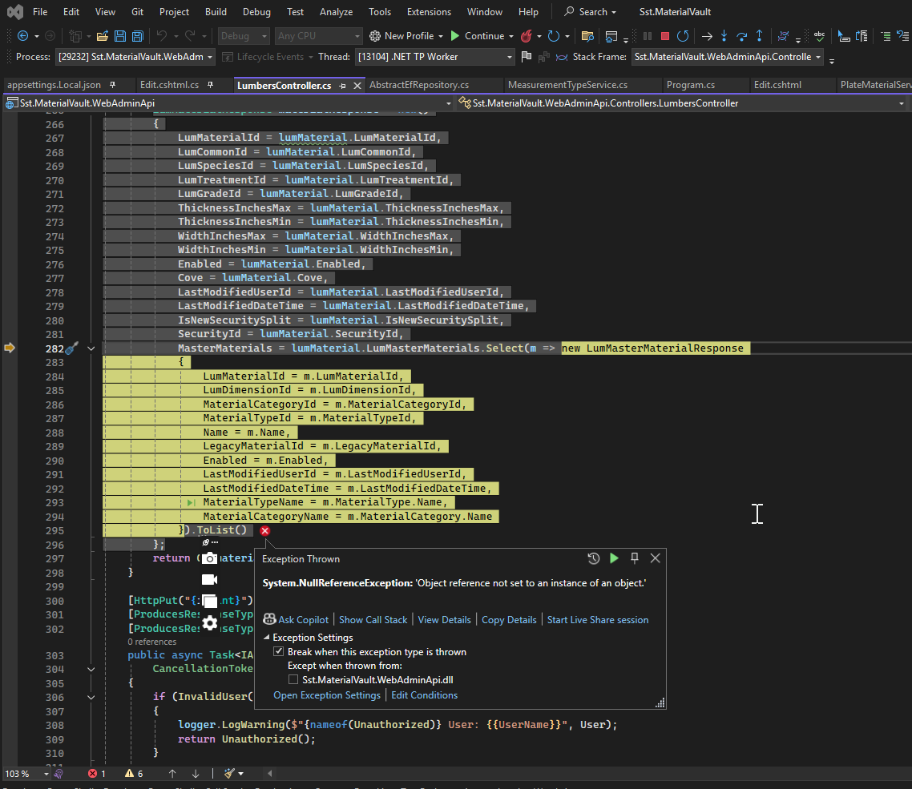

GET/POST Lumber> Dimensions
There is an error retrieved
{
"measurementTypeId": 1,
"thicknessInches": 1,
"thicknessNominal": 2,
"widthInches": 5,
"widthNominal": 2,
"enabled": true,
"lastModifiedUserId": 0,
"lastModifiedDateTime": "2025-07-11T20:45:27.887Z"
}



