Acceptance Criteria (ADO)

1. Remove Commons dropdown from create and edit screens
2. Select current active common for xxCommonId.
3. Triple check no other changes in other api's, etc.

Issue #1 Glulams > Commons Notice that remove and add new Common still present on this screen
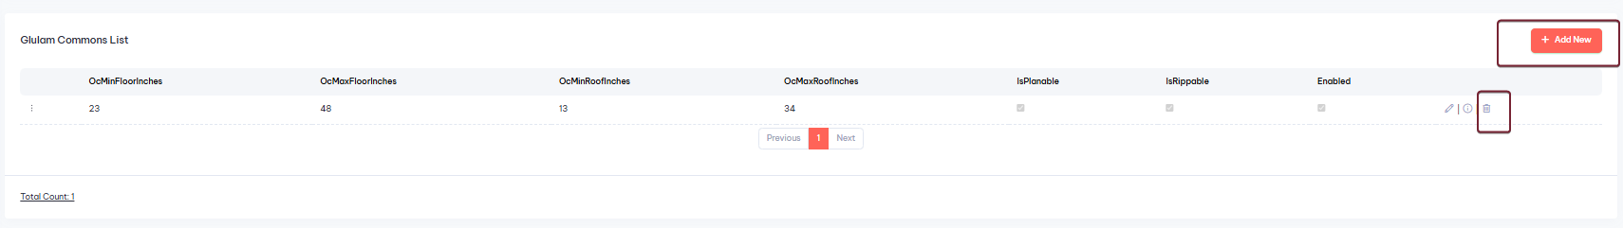
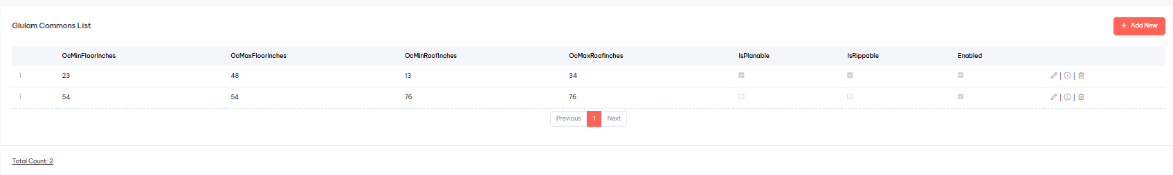
Issue #2 Lumbers > Commons Notice that remove and add new Common still present on this screen

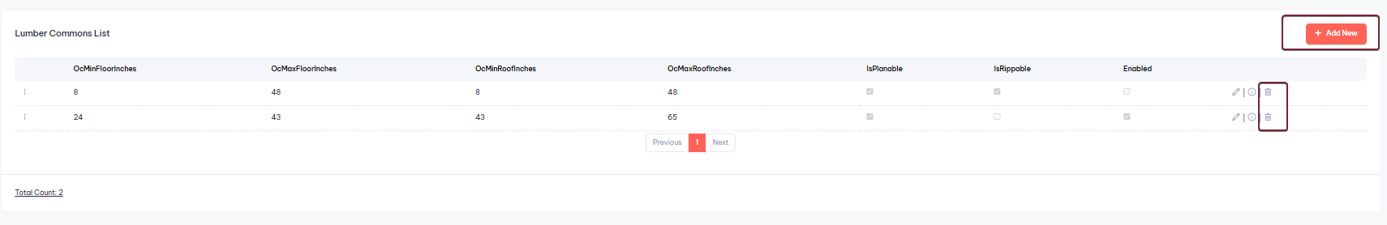
Edit Lumbers > Dimensions is giving an error
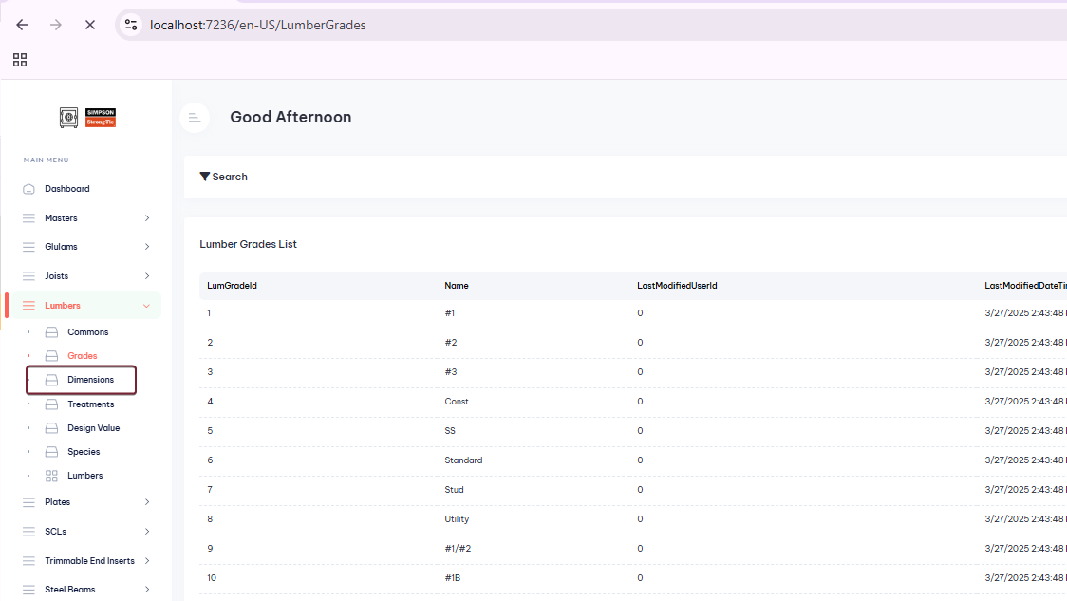
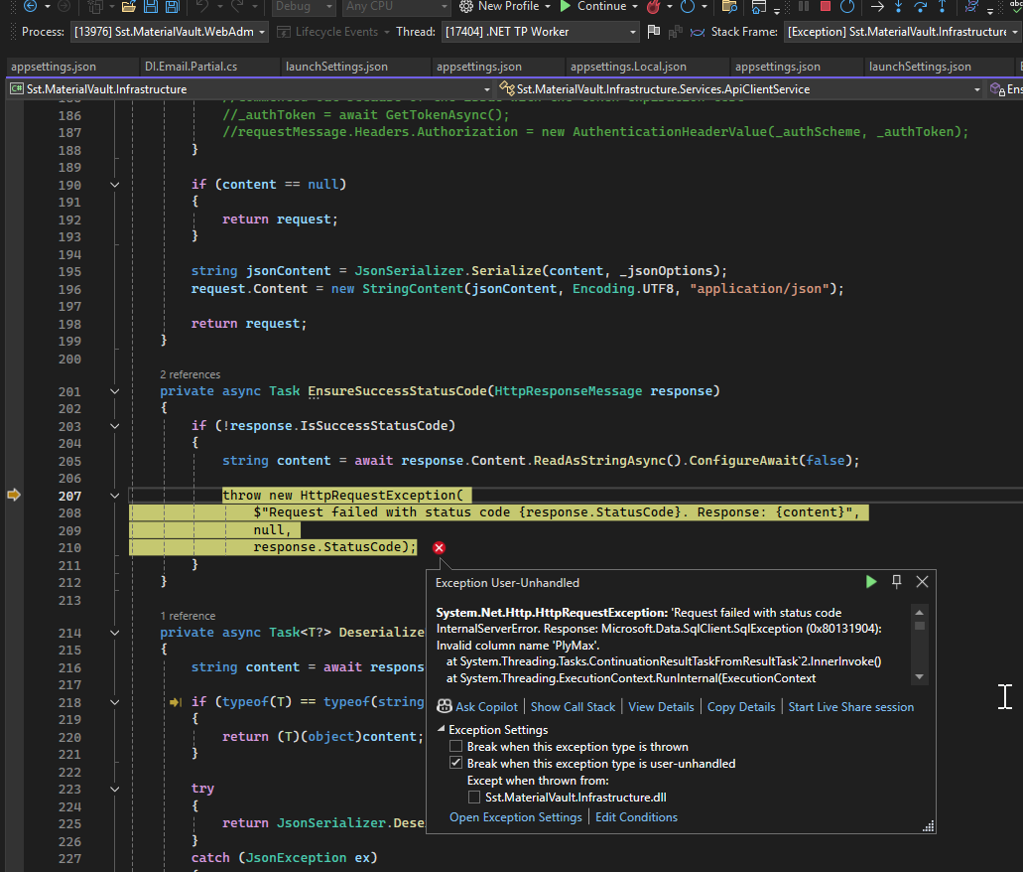

Issue #3 Plates > Commons Notice that remove and add new Common still present on this screen

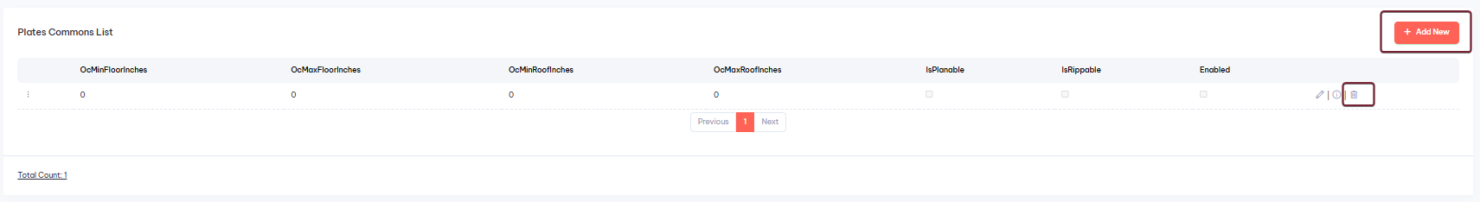
Issue #4 Add new Plate is not creating a new Plate
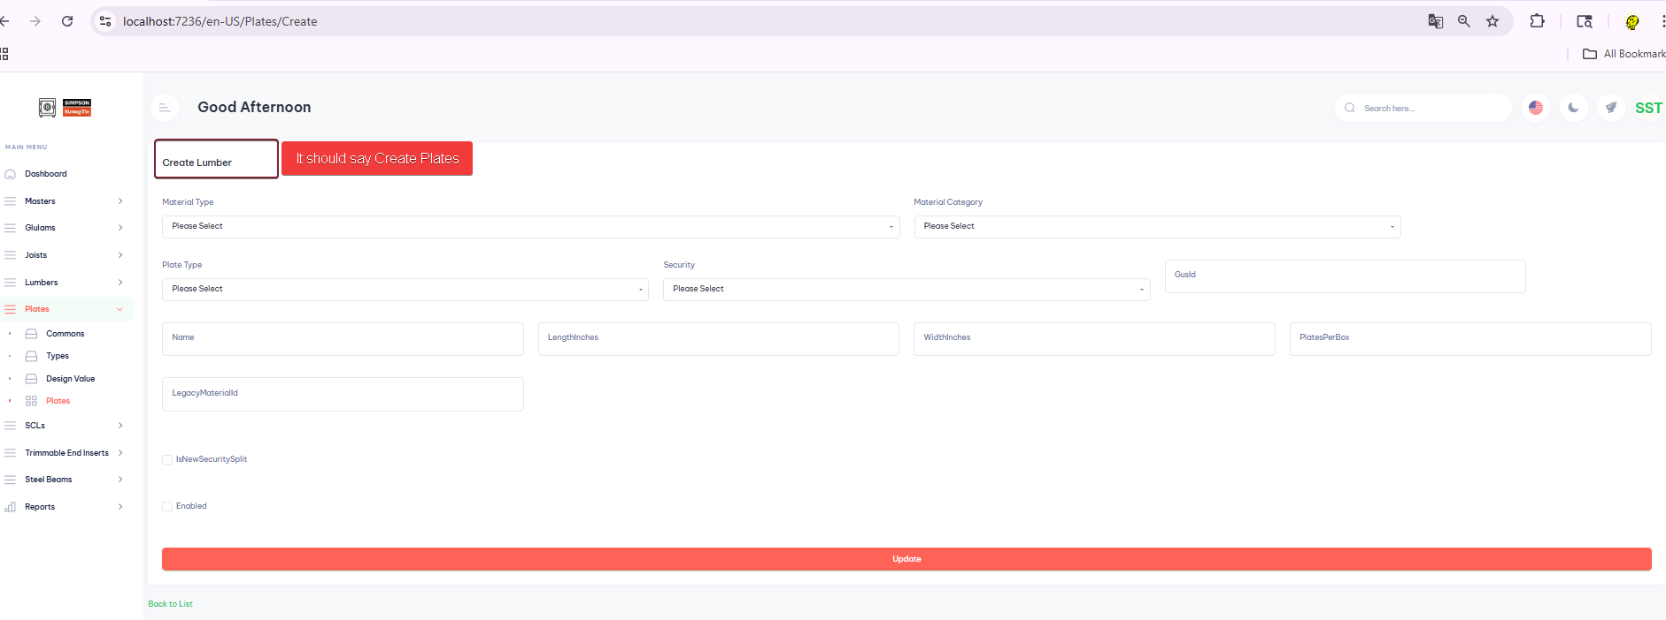
Fill the respective fields
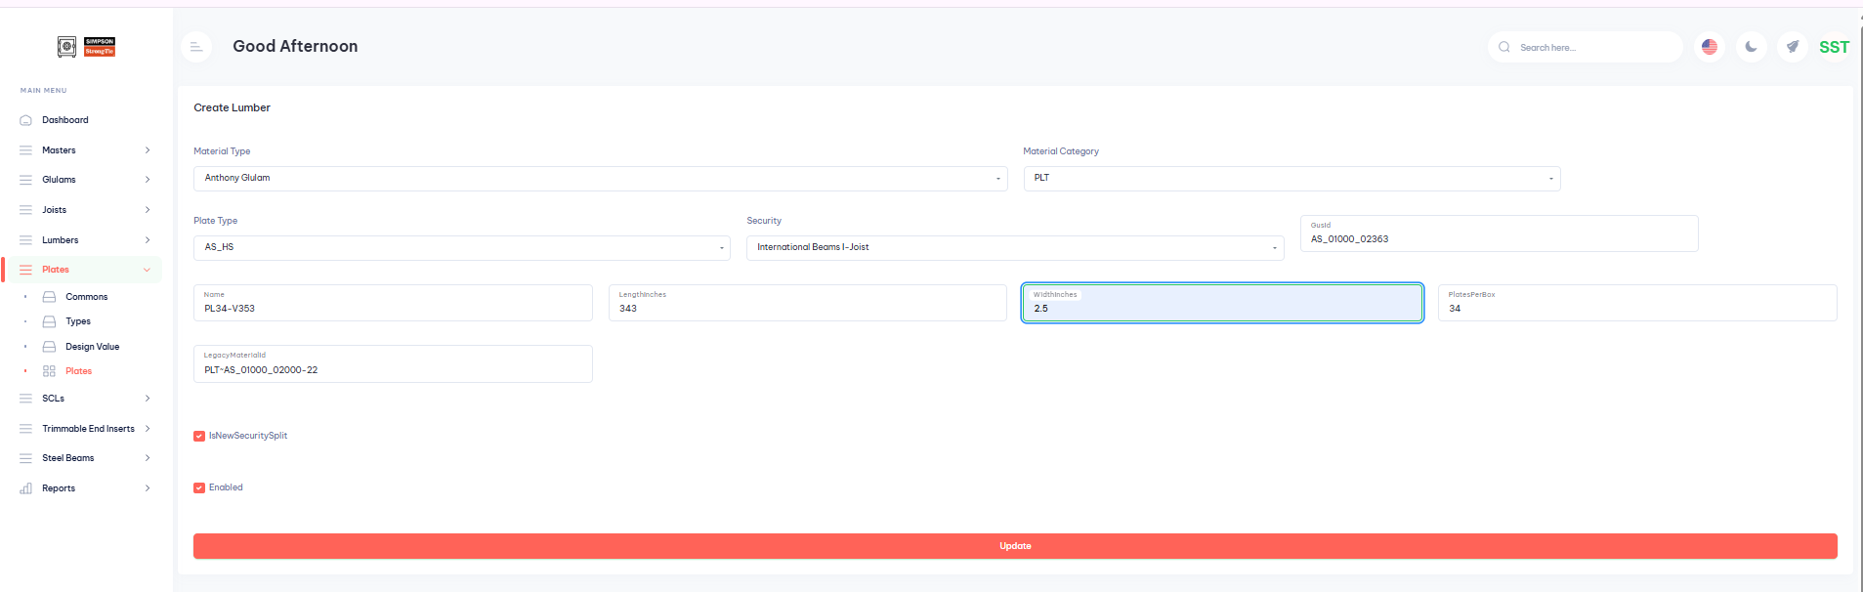
Click on Update

Some fields are emptied, and no actions occurs
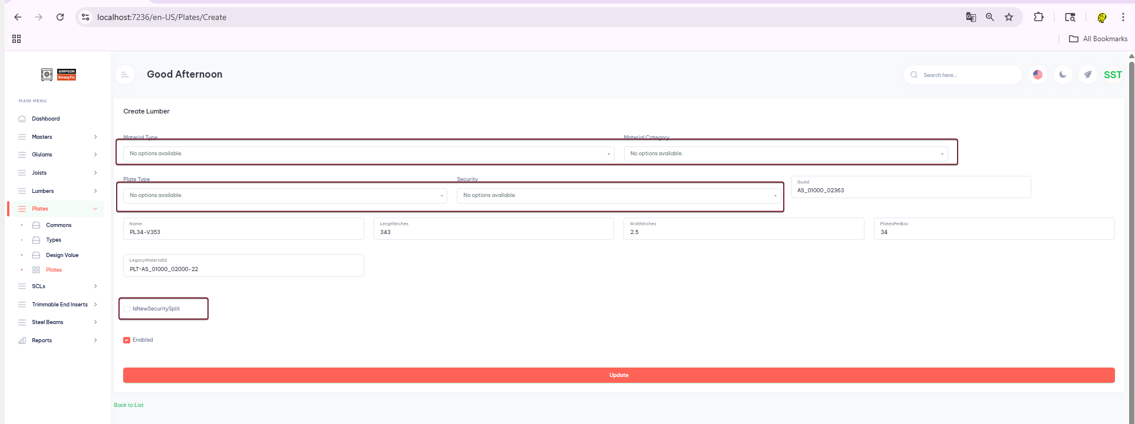
Issue #5 There are no SBL Commons row. It should display at least one
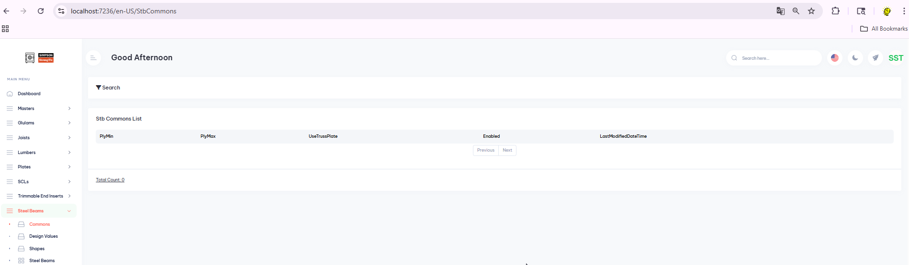
Issue #6 Error when clicking on SBL > Design Values
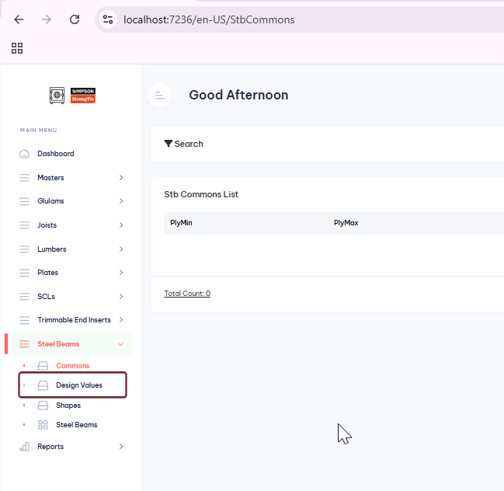
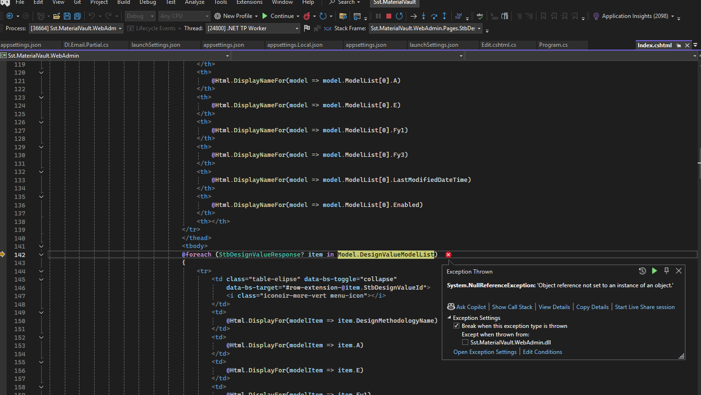

Issue #7 Unable to create a new STB> Shapes
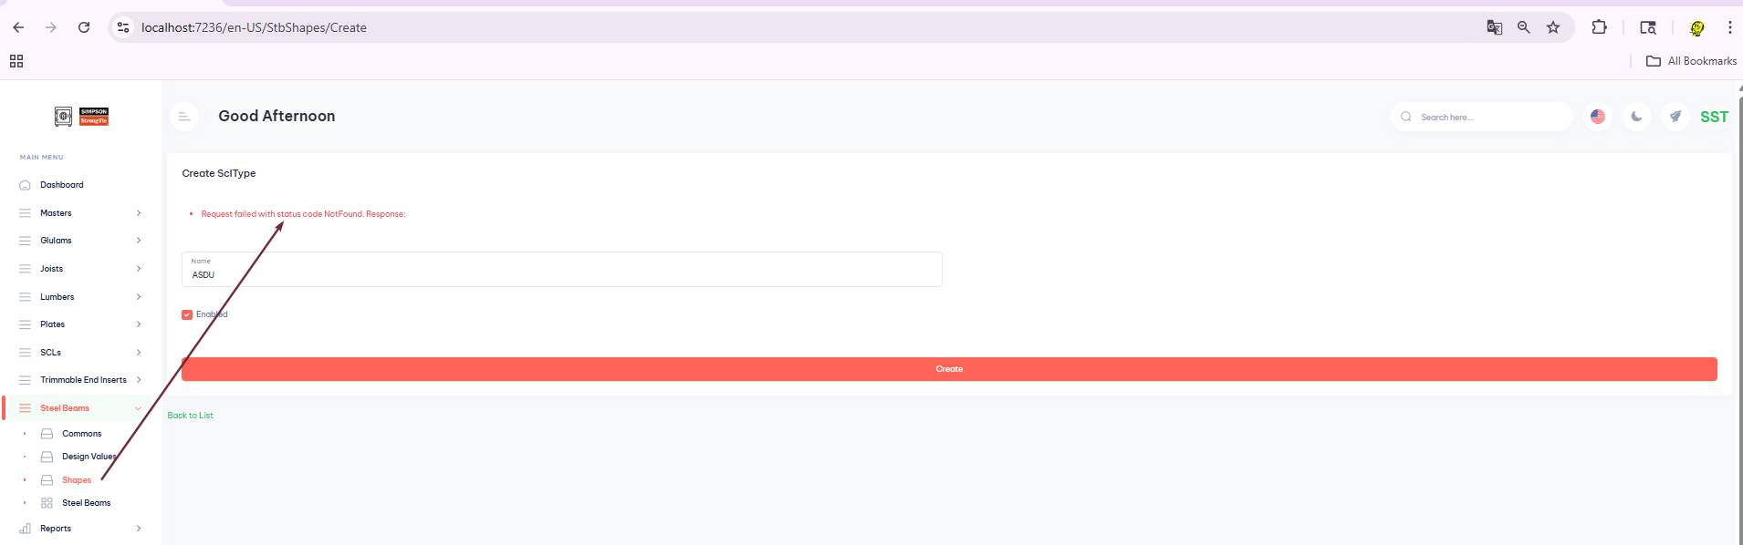

Issue #8 Error when clicking new SBT > Add new


